

-

International School
CAPSTONE PROJECT 1
CMU-SE 450
ARCHITECT DESIGN DOCUMENT
Clinic Booking
Clinic Booking and Management System using Chatbot and Voice Assistant
Submitted by: C1SE.62

Architect Design Review Panel Representative:
Name: Signature Date
Capstone Project 1- Mentor:
Name: Msc.Nguyen Trung Thuan Signature Date

PROJECT INFORMATION

Project acronym | CB
Project Title | Clinic Booking
Start Date | September 6,  2024 | End Date | December 20,  2024
Lead Institution | International School, Duy Tan University
Project Mentor | Msc.Nguyen Trung Thuan
Scrum master  / Project Leader & contact details | Doan Hoang Quan  Email: quandoan.140203@gmail.com Tel: 0905413819  ID: 27211242264
Partner Organization | Duy Tan University
Team members | Name | Email | Tel
27211248324 | Manh, Vo Van | vanmanh23012003@gmail.com | 0905118140
27211242264 | Quan, Doan Hoang | quandoan.140203@gmail.com | 0905413819
27211201526 | Lich, Huynh Ngoc | huynhngoclich10052003@gmail.com | 0935513362
26201241995 | Vy, Nguyen Yen | vyzit112002@gmail.com | 0775513141
27211221365 | Kien, Tran Trung | trantrungkien6@dtu.edu.vn | 0368313577

REVISION HISTORY
Version | Date | Comments | Author | Approval
1.0 | 03/10/2024 | Initial Release | Doan Hoang Quan
1.1 | 10/11/2024 | Update document | Doan Hoang Quan

Table of Contents

- Introduction 7
  - Project overview 7
  - Purpose 7
  - Business driver 8
- Architecture driver 8
  - Business constraints 8
  - Technical constraints 8
  - Functional requirement 9
  - Quality attributes 9
    - Utility table 9
    - Quality attributes 9
- Architecture overview 13
  - System context 13
  - Component and connector 14
  - Activity diagram 16
    - View List of Doctors 16
    - View User Detail 17
    - Manage EHR 18
    - Make an appointment 19
    - Update account 20
  - Sequence diagram 20
    - Login 21
    - Registration 21
    - View List of Doctors 23
    - View User Detail 24
    - Manage Electronic Health Records 25
    - Make an appointment 26
    - Update Account 27
  - Module view 28
  - Allocation view 29
- ATAM 30
  - Present the ATAM: 30
  - Present the business Drivers 31
  - Present the Architecture: 31
  - Identify the Architecture approaches: 31
  - Create a Quality Attribute Tree: 31
  - Analyze the Architectural approaches: 31
  - Brainstorm and prioritize scenarios: 32
  - Re-analyze the architectural approaches: 32
  - Present the results: 32
- References: 32

Figure
Figure 1. System Context Overview 13
Figure 2. C&C for Clinic Booking Website 14
Figure 3. View List of Doctors Activity diagram 16
Figure 4. View User Detail Activity diagram 17
Figure 5. Manage EHR Activity diagram 18
Figure 6. Make an appointment Activity diagram 19
Figure 7. Update account Activity diagram 20
Figure 8. Login Sequence diagram 21
Figure 9. Registration Sequence diagram 22
Figure 10. View List of Doctors Sequence diagram 23
Figure 11. View User Detail Sequence diagram 24
Figure 12. Manage EHR Sequence diagram 25
Figure 13. Make an appointment Sequence diagram 26
Figure 14. Update Account Sequence diagram 27
Figure 15. Module View for Clinic Booking WebsiteProse 28
Figure 16. Allocation View for Clinic Booking Website 29

Table:

Table 1: Changes login password 9

Table 2: Personal information 10

Table 3: Multiple action with Chatbot 10

Table 4: Consult about the illness 11

Table 5:Trouble booking an appointment 11

Table 6: Acess the system 24/7 to make appointments 12

Table 7: System automatically updates and maintains 12

Table 8: The number of users increased suddenly 12

Introduction

Project overview
- The Clinic Booking is developed to improve the patient experience and clinic management efficiency. The project provides solutions for online appointment scheduling, patient information management, personal Electronic Health Records, and support doctors in medical examination and treatment for both users (athletes, teams, individuals) and facility managers by providing an intuitive, user-friendly interface and robust backend support.

Purpose
- For Users: Provide a user-friendly platform where patients can easily search for doctor information, doctor working schedules, and manage their personal Electronic Health Record. The application will offer intuitive navigation, advanced search filters, and real-time availability updates to make the booking process seamless. Moreover, the Chatbot and Voice Assistant enables personalized advice, help patients enter Electronic Health Records (EHR) using voice, and 24/7 availability.
- For Doctors: Provide a user-friendly platform where doctors can easily search for patient information, manage working schedules and patient’s Electronic Health Record. The application will offer Chatbot and Voice Assistant in personalized support, enter patient’s EHR using voice, support doctors in managing information and schedules, and 24/7 availability.
- For Administrator: Offer tools to efficiently manage bookings, schedules, and facility maintenance, reducing the administrative burden and minimizing errors.
  - Increase Facility Utilization: Ensure clinic facilities are used to their maximum potential by making them more accessible to a broader audience. The platform will help manage doctor schedules better and reduce idle times, increasing revenue for facility owners.
  - Create a positive and engaging experience for users by providing convenient features such as instant booking confirmations, reminders, personalized advice by Chatbot, and enter EHR using voice. The application aims to build a loyal user base by meeting their needs effectively.
  - Provide Comprehensive Management Tools: Equip administrator with a powerful dashboard that includes analytics, reporting, and management capabilities. These tools will help in making informed decisions, tracking performance, and ensuring smooth operations.
  - Foster Community and Engagement: Encourage community engagement through features like reviews, ratings, and social sharing. Users can share their experiences, and read reviews, fostering a sense of community and trust within the platform.
  - Secure and Reliable Transactions: Ensure that all financial transactions, personal data, and user information are handled securely. The application will integrate with trusted payment gateways and implement robust security measures to protect user data.

  - Adaptability and Scalability: Design the application to be scalable and adaptable to various clinic and facility types. This flexibility will allow the platform to grow and evolve with user needs and market trends.

Business driver
- Business Problems:
  - Manual and Time-Consuming Bookings: Traditional methods of booking clinics, such as phone calls or in-person reservations, are time-consuming and prone to errors. This inefficiency can lead to double bookings, missed appointments, and dissatisfied customers
  - Lack of Real-Time Availability: Users often face difficulties finding available appointments due to outdated or inaccurate information about doctor schedules.
  - Underutilized Facilities: Many clinics remain underutilized because of ineffective marketing and lack of visibility. Facility managers struggle to reach potential customers and have appointments with them.
  - Revenue Loss: Underutilization directly impacts revenue generation. No appointment means missed opportunities for earning potential.
  - Complex Administrative Tasks: Facility managers have to handle a multitude of tasks, including booking management, payment processing, scheduling, and maintenance. Without effective tools, these tasks can become overwhelming and lead to operational inefficiencies.
  - Data Management Challenges: Keeping track of user data, booking history, and financial transactions manually or through disparate systems can result in data inconsistencies and difficulties in generating insightful reports.
  - Insecure Payment Processes: Traditional payment methods can pose security risks, leading to potential financial losses and decreased trust among users.
  - Complicated Booking Interfaces: Users may abandon the booking process if the interface is not user-friendly or if the process is too complicated.
  - Lack of Communication: Users often do not receive timely notifications about their bookings, leading to missed reservations or confusion.
  - Limited User Engagement: Without a proper feedback system, facility managers miss out on valuable insights from users that could help improve services and customer satisfaction.

Architecture driver

Business constraints
- Sources: 5 people.
- Project was started on: 06/09/2024.
- Project will be ended on: 15/12/2024.
- Project will be finished in 100 days.
- Cost: $4596.

Technical constraints
- Technical To Develop:
  - Programming Language: JavaScript, Java.
  - Frameworks / Libraries: ReactJS, Bootstrap, Spring Boot.
  - Database Management System: MySQL.

- Environment:
  - Web browsers: Google Chrome, Cốc Cốc.
  - Development : Visual Studio Code, Intellij

Functional requirement
    - Register and Login: Users can create accounts and log in to fully use the system's functions.
    - Booking and search with Chatbot: Users can easily book an appointment with a doctor via AI Chatbot, search for diseases, doctors information and their schedule.
    - Detailed information about Electronic Health Records (EHR): Our system provides comprehensive details about Patient information, Medical history, Current diagnosis and treatment, Laboratory data, Imaging data, Hospitalization and surgical history, Vaccination history, and Clinical notes.
    - Enter Electronic Health Records using Voice Assistant: Voice Assistant seamlessly integrates with Electronic Health Records to support patients and doctors enter patient’s Electronic Health Records easily.
    - Reservation management: Admin have access to a dedicated dashboard where they can manage bookings, view patient information and update doctor‘s schedules. This feature also ensures efficient management of bookings and helps doctors track their schedules easily.
    - Notification and reminder system: Our system incorporates a notification and reminder system to inform patients and doctors about upcoming bookings, changes in schedules or any important updates.
    - Feedback and reviews: We value user feedback and encourage users to share their experiences by providing ratings and reviews of the sports fields they have visited.

Quality attributes

Utility table
- There are following quality attributes that drive the design of architecture. Each quality attribute scenario is ranked with importance (I) defined by the Product Owner, and the estimated level difficulty (D). Both values are based on a scale of High (H) - Medium (M) - Low (L).

Quality attributes
      - Security
Table 1: Changes login password

Situation: User changes login password
Type | Security
Stimulus | User requests to change login password
Source of stimulus | User

Environment | Stable network and server
Artifact stimulated | Security system
Response | Confirm and store the new password
Response measure | New password processing and confirmation time

Table 2: Personal information

Situation: User enters personal information (full name, phone number,...)
Type | Security
Stimulus | Users will keep their information confidential.
Source of stimulus | User
Environment | Stable network and server
Artifact stimulated | Register user information management system
Response | Log and confirm changes
Response measure | Log accuracy and processing time

      - Performance
Table 3: Multiple action with Chatbot

Situation: User performs multiple action queries with Chatbot in a short period of time
Type | Performance
Stimulus | Users perform multiple action queries in quick succession
Source of stimulus | User
Environment | Stable internet
Artifact stimulated | Chatbot
Response | Displays results for each query

Response measure | Processing time and accuracy of each result

      - Usability
Table 4: Consult about the illness

Situation: User wants to consult about their illness as well as make an appointment.
Type | Usability
Stimulus | Users want to consult about their illness as well as make an appointment.
Source of stimulus | User
Environment | User-friendly interface
Artifact stimulated | Interface for Chatbot consultation and appointment.
Response | Chatbot should respond promptly and allow users to book appointments or get advice in a few simple steps.
Response measure | Response time
      - Reliability
Table 5:Trouble booking an appointment

Situation: User has trouble booking an appointment but has already been booked.
Type | Reliability
Stimulus | Users report technical problems and want quick recovery
Source of stimulus | User
Environment | Stable internet and server
Artifact stimulated | System
Response | Restore normal function
Response measure | Recovery time and confirmation of normal functioning

      - Availability
Table 6: Acess the system 24/7 to make appointments

Scenario: User wants to access the system 24/7 to make appointments.
Type | Availability
Stimulus | Users want to access the system anytime, anywhere
Source of stimulus | User
Environment | Stable internet and server
Artifact stimulated | System
Response | The system is always available for access
Response measure | Uptime and accessibility confirmation

Table 7: System automatically updates and maintains

Quality attributes: The system automatically updates and maintains
Type | Availability
Stimulus | The system is automatically updated and maintained on weekends
Source of stimulus | System
Environment | Stable internet and server
Artifact stimulated | System
Response | The system automatically updates and maintains
Response measure | Update time and accessibility once completed
      - Scalability
Table 8: The number of users increased suddenly

Quality attributes: The number of users suddenly increased and the system needed to expand to meet demand.
Type | Scalability

Stimulus | The number of users increased suddenly
Source of stimulus | Sudden increase in the number of users
Environment | Stable internet and server
Artifact stimulated | System
Response | Expand the system to meet demand
Response measure | Expansion time and post-expansion performance evaluation

Architecture overview
- This section shows the diagrams which bounds our target system and describes the architecture and interaction between components

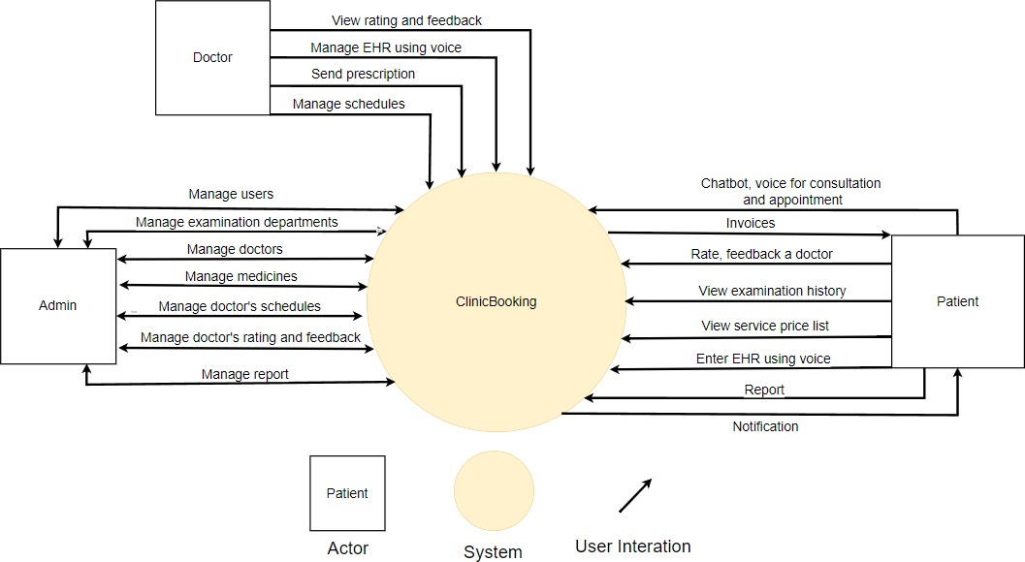
System context
Figure 1. System Context Overview

User:
    - Request Register, Login/Logout to the system, the system check information and response.
    - Request to update, delete,add,edit account information.
    - Request to use Chatbot, voice for consultation and appointment.
    - Request to view list of doctors information.
    - Request to rate and feedback a doctor.
    - Request to enter EHR using voice.
    - Request to view appointment history.
    - Request to get the notification.

Doctor:

    - Request Register, Login/Logout to the system, the system check information and response.
    - Request to update, delete,add,edit account information.
    - Request to use Chatbot, voice for consultation and manage patient’s EHR.
    - Request to manage schedules.
    - Request online prescription delivery to patients.
    - Request to view rating and feedback.

Admin:
    - Request Login/Logout to the system, the system check information and response.
    - Request to manage doctor.
    - Request to manage user as block or delete user account.
    - Request to manage appointment.
    - Request to manage doctor’s rating and feedback.
    - Request to manage medicine.
    - Request to manage report.

Component and connector
    - We mainly used a C&C view to argue and reason about architectural properties, quality attribute requirements, and functional requirements that the system must add here.
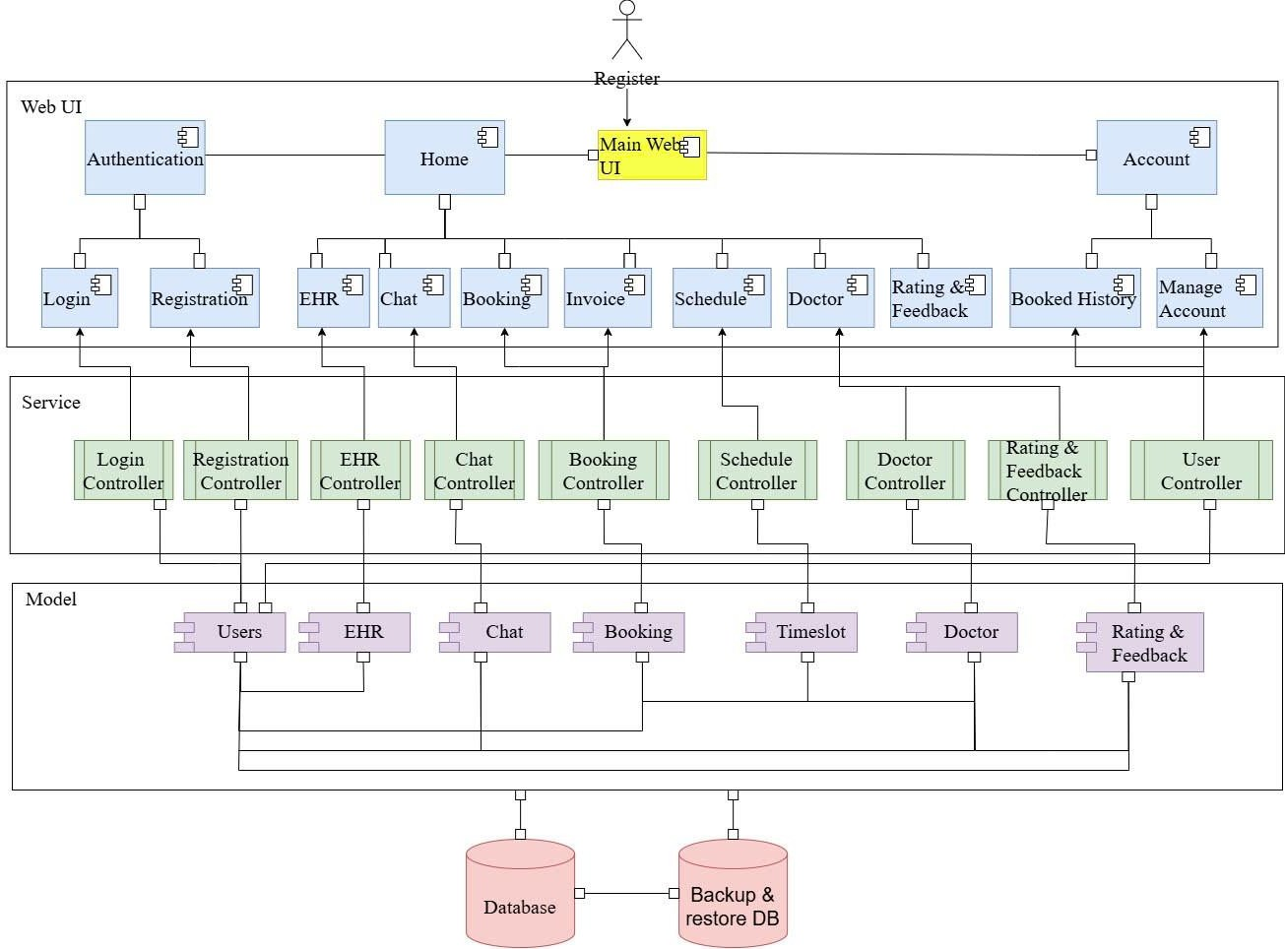

Figure 2. C&C for Clinic Booking Website

- This view type partitions the system into components that have some runtime presence such as processes, objects, data stores, and connectors or that represent pathways of communication such as data flows and access to shared storage.

Prose
  - The web client sends and receives data from the server through the web service API. User operations will send requests to the server through the API, the server will process the data with the corresponding models and access the database to retrieve data, then respond to the information to the web client through the API to display it to the user

Element | Responsibilities
Web UI | - Web UI is a component that manages and implements interactive functions for users that are handled on the UI. Web Clients interact directly with users, receive requests and call APIs from Web Service  to handle and return results.
Web Service | - Web Service is the component responsible for handling requests from users, implementing application logic, and managing interactions  between Model and Web UI, it ensures separation between data, business logic, and user interface.
Model | - Model is the component responsible for data management, business logic and notification of data changes to other components, it keeps data and business logic independent of how they are displayed or  interacted with on the user interface.
Database | - Database is a component which contains information of users, doctors, news, question, comment,... All data the system needs
Folder | - The place to store all image in the system.

Activity diagram

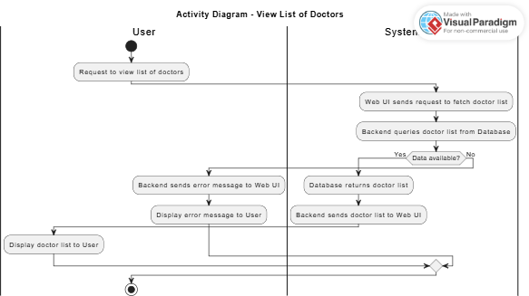
View List of Doctors

Figure 3. View List of Doctors Activity diagram

Explanation:
        - |User| and |System|:
        - Create a swimlane that clearly separates user and system activities.

Activity flow:
  - User makes a request to view a list of doctors.
  - System sends requests to the backend → query database → process results.

Based on data:
  - With data: Display list of doctors.
  - Without data: Display error message.

Branching logic:
  - Use if to determine if there is or is not data.

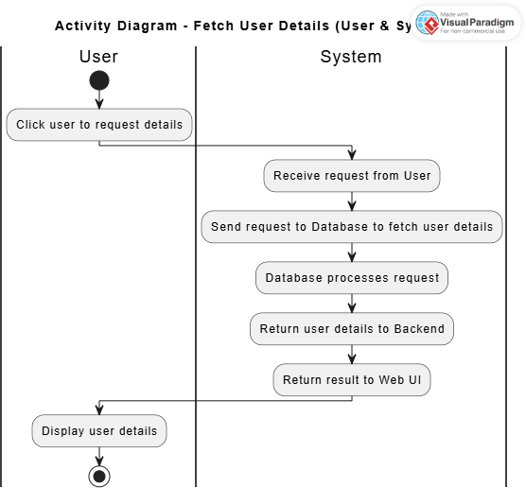
View User Detail

Figure 4. View User Detail Activity diagram

Explain the parts:
        - |User| and |System|:
        - Use swimlane to separate the two parts:
        - User: The activities that the user performs.
        - System: The tasks that the system processes.

Steps of operation:
  - The user clicks on the interface to request detailed information.
  - Web UI sends a request to Backend.
  - Backend sends a query to the Database to get a list of detailed information.
  - The Database returns the result to Backend → sends it to Web UI.
  - Web UI displays detailed information to the user.

Clear flow:
  - The steps in the system are divided into clear blocks on the swimlane.

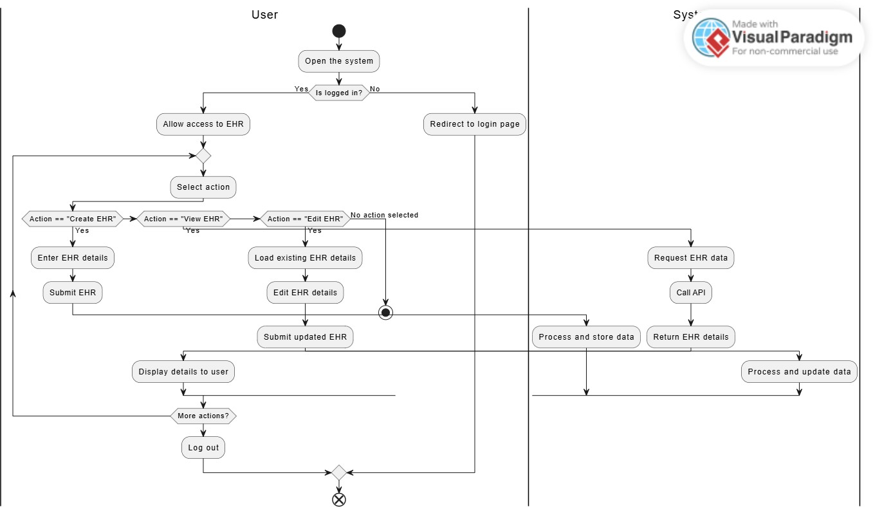
Manage EHR

Figure 5. Manage EHR Activity diagram

Explain the flows:
  - Start:
    - User opens the system.

Login Check:
    - Yes: Access granted to the EHR system.
    - No: Redirect to the login page.

Select Action:
    - Create EHR: Enter details → Submit → System processes and stores data.
    - View EHR: System fetches data → Displays to user.
    - Edit EHR: Load existing data → User updates → Submit → System updates data.

Results:
    - Updated details are displayed to the user.

More Actions:
    - Yes: Repeat actions.
    - No: Log out.

End:
    - Process concludes.

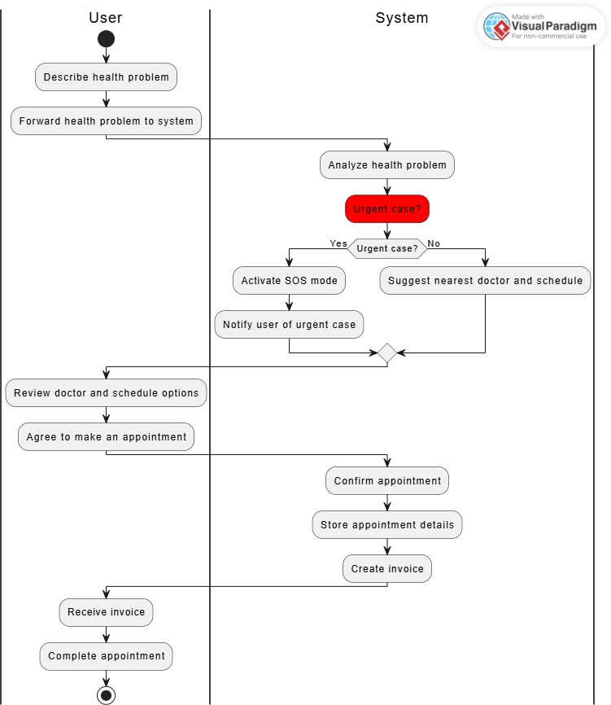
Make an appointment

Figure 6. Make an appointment Activity diagram

Explain:
  - User:
    - Describes health problem.
    - View doctor suggestions and appointments.
    - Accepts appointments.
    - Receives invoice and completes appointment.

System:
    - Analyzes health problems.
    - Determines:
    - Urgent: Activates SOS mode, notifies the user.
    - Non-urgent: Suggests doctor and appointments.
    - Confirms appointment, saves information, generates invoice.

Decision:
    - Process branch: Urgent or Non-urgent.
    - The process ends when the appointment is completed.

Update account
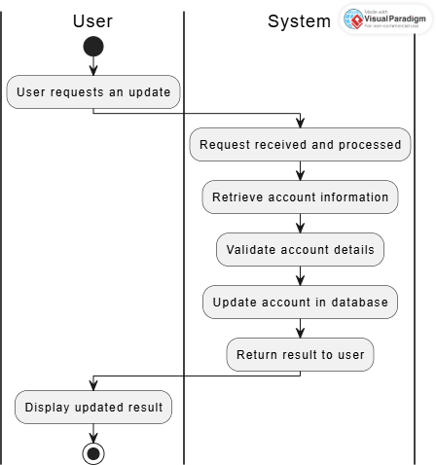

Figure 7. Update account Activity diagram

Explain the flow:
  - Start:
    - The process begins with the User requesting an update.

User Actions:
    - Sends an Update Request to the system.
    - Receives and Displays Result after processing.

System Actions:
    - Request received: Processes the user's request.
    - Retrieve Account: Fetches account details from the database.
    - Validate: Validates the retrieved data.
    - Update Account: Updates account information in the database.
    - Send the Result back to the user.

End:
    - The user views the updated result, and the process ends.

Sequence diagram
    - Sequence diagram is used to display the sequence of activities. Sequence diagrams show the workflow from a start point to the finish point detailing the many decision paths that exist in the progression of events contained in the activity.

Login
      - Description:
        - To use the system's functionality, users must first log in with email and password. Our system receives the request, authenticates it, and responds with the results. If logged in successfully, users can use all system functions within their permission. Otherwise, their access will be denied.
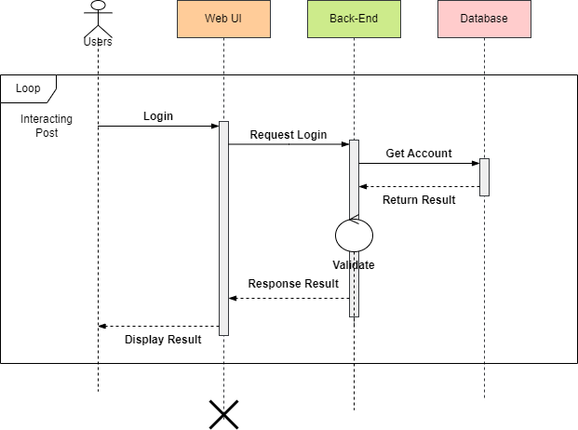
Figure 8. Login Sequence diagram

Registration
      - Description:
        - To login to the system, users have to register firstUsers are allowed to register a new account, to do that they create a new account with email, password and name.

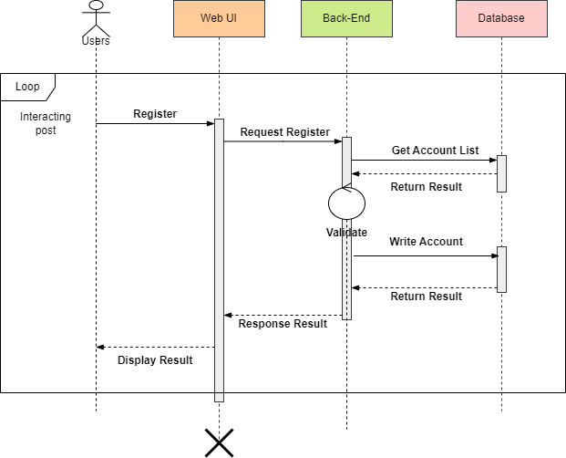
Figure 9. Registration Sequence diagram

View List of Doctors

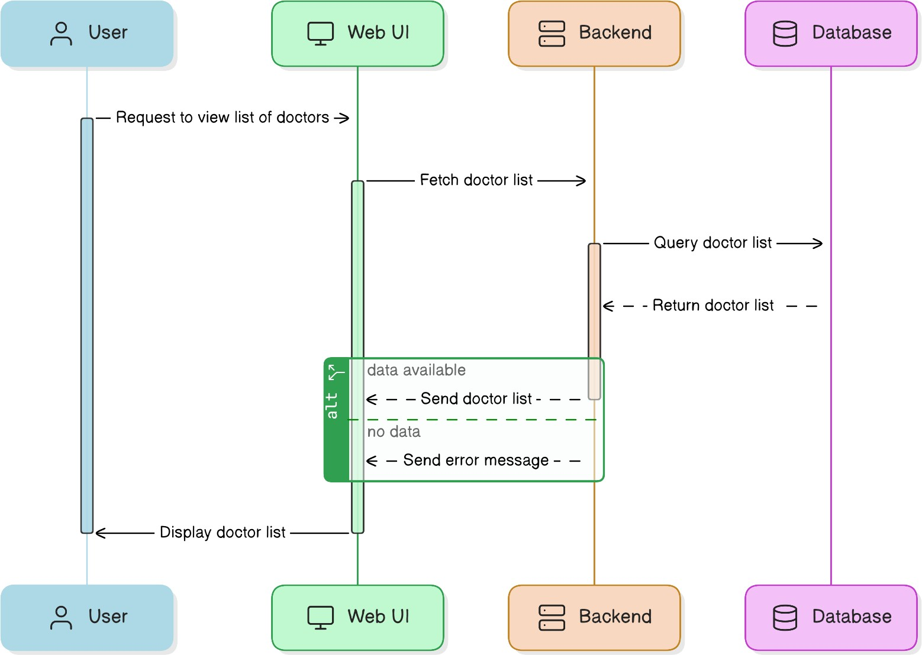

Figure 10. View List of Doctors Sequence diagram

Description:
        - Users are allowed to view a list of doctors in the system, our service receives requests, calls API to get data and returns a list of doctors to the user interface.

View User Detail
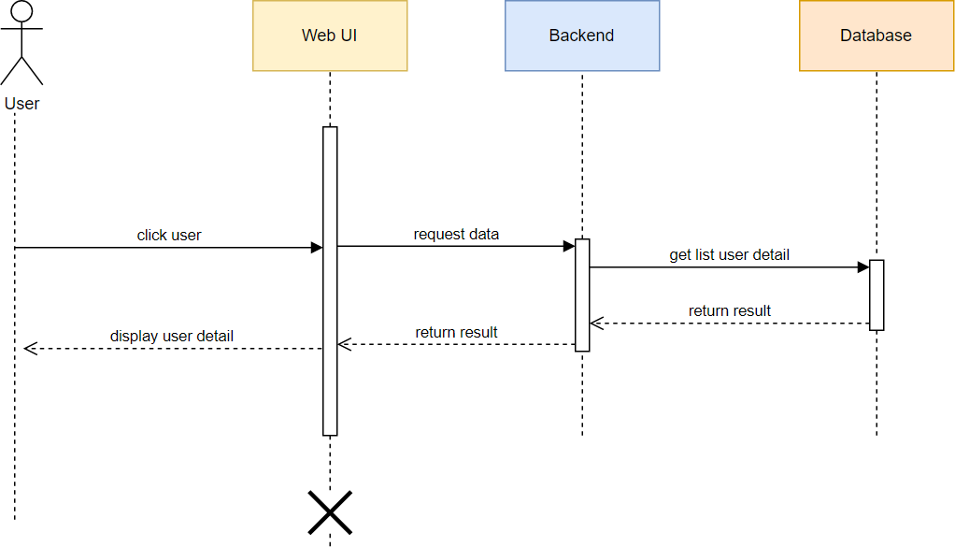
Figure 11. View User Detail Sequence diagram

Description:
        - Users are allowed to view User detail in the system, to do that they have to let the system know which User they want to view detailed information. Our service receives requests, calls API to get data and return User detail information.

Manage Electronic Health Records
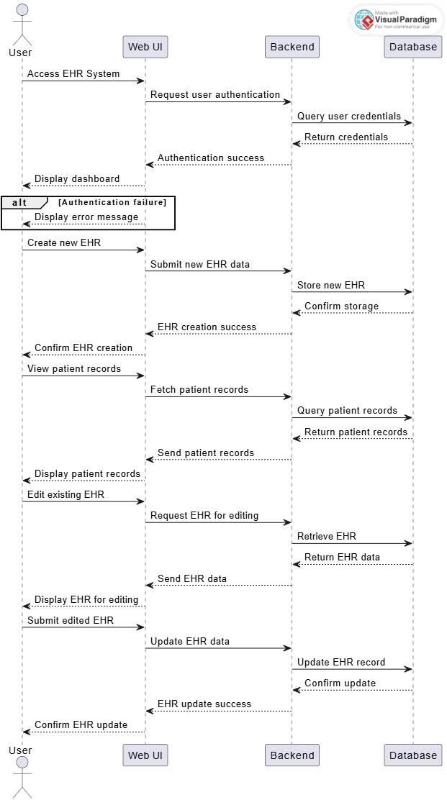
Figure 12. Manage EHR Sequence diagram

Description:
        - Users are allowed to view their EHR detail in the system, to do that they need to login to the system, after that they can manage EHR in

many ways: create, view and edit. Our service receives requests, calls API to get data and return detail information.

Make an appointment
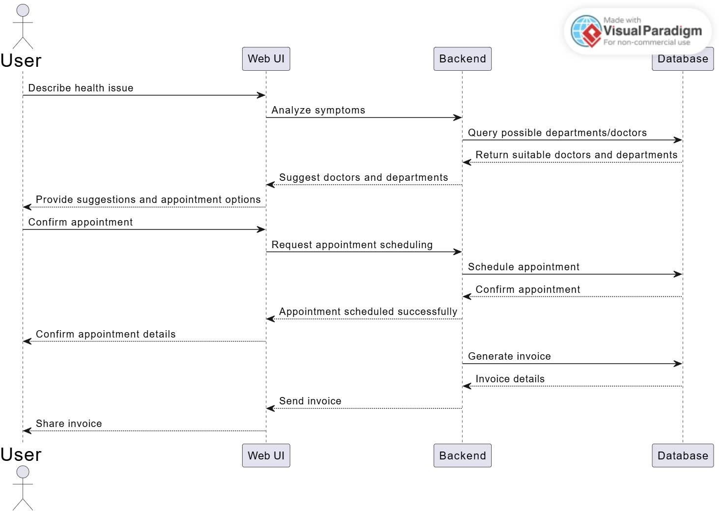
Figure 13. Make an appointment Sequence diagram

Description:
        - The user tells the chatbot about their health problem, then the chatbot will determine whether the user's case is urgent or not. If so, it will activate SOS mode. If not, the chatbot will suggest their nearest doctor and schedule. If the user agrees to make an appointment, the system will create an invoice and send it to the user and confirm the appointment is completed.

Update Account
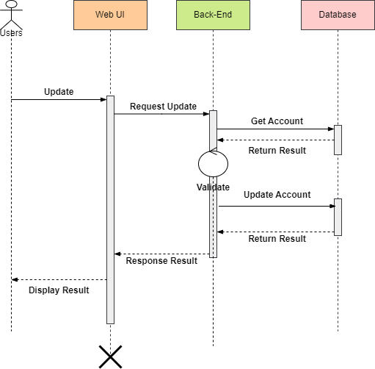
Figure 14. Update Account Sequence diagram

Description:
        - To update an account, users have to login first.
        - Users are allowed to update their account information by changing information such as password, name, avatar,.. If the information is valid, the system will inform the user interface and update the data to the database, otherwise the system will inform an error and refuse to update.

Module view

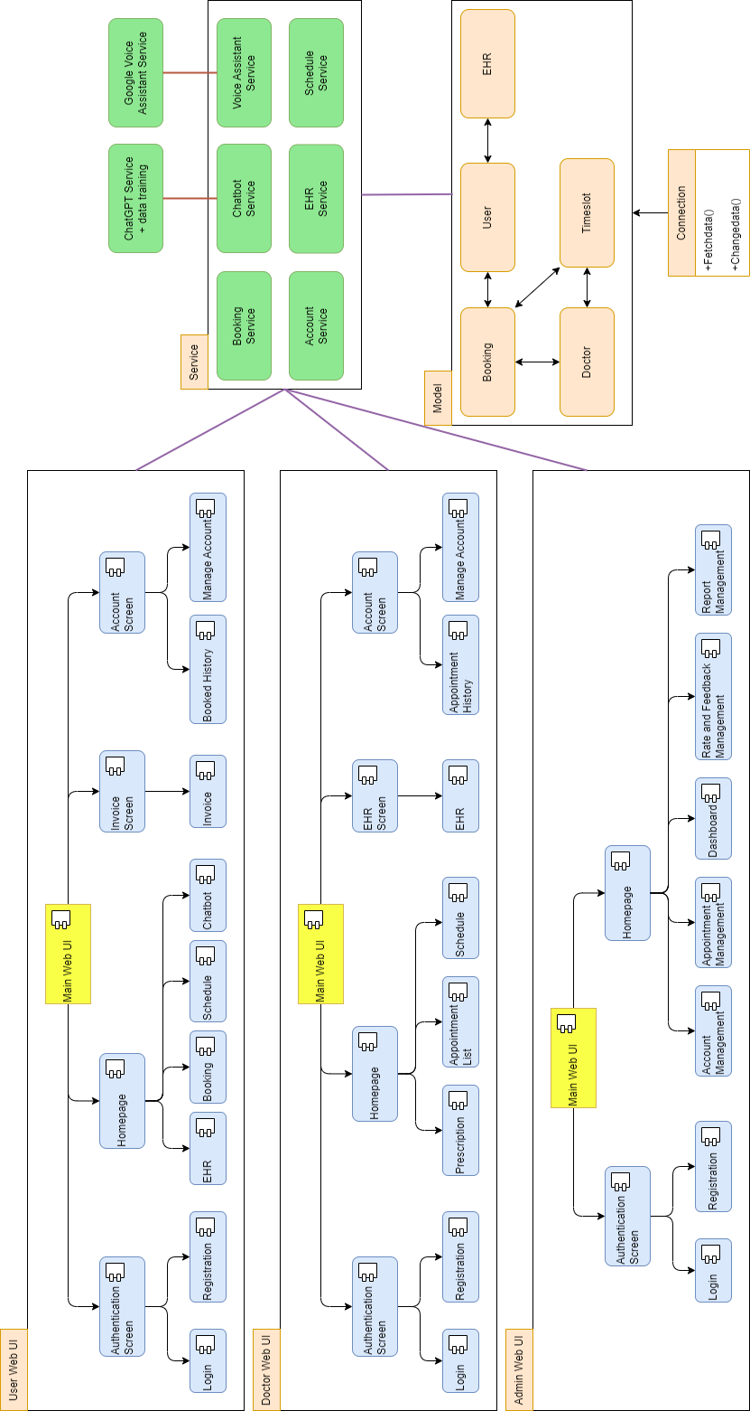

Figure 15. Module View for Clinic Booking WebsiteProse

o The system includes Web View(UI), Services and Models. After users interact with UI, data will be requested to the corresponding service, then will direct to model or AI model. Data be responded will be displayed on UI.

Element | Responsibilities
Web View | The website package contains management modules for admin, user and doctor.
Service | Developed by Spring Boot. It will responsible for handling requests from users and connect and query data from MySQL database.
Model | Object data modules connect to tables in the database for transmission to the system interface by using service API.
AI Model | The AI Model will be responsible for verifying the validity of the photo uploaded by the user. Based on this photo, the AI model will diagnose skin diseases for the user through pre-trained data in the system.
Folder | The place to store all image in the system.

Allocation view
    - The allocation view models the run-time architecture of a system. It shows the configuration of the hardware elements when the system is deployed.
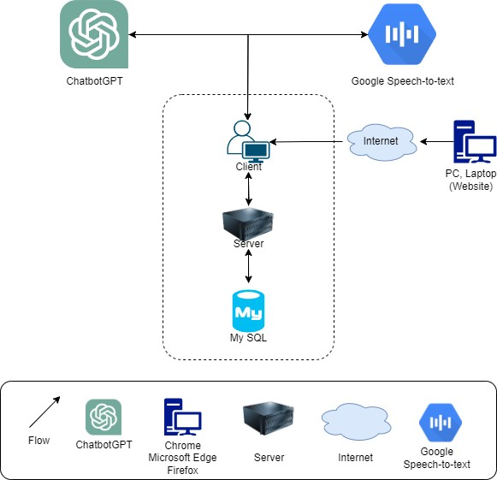

Figure 16. Allocation View for Clinic Booking Website

Prose
  - The system is deployed on a website environment (using React JS). It interacts with the server through APIs to read and write data from the MySQL database.

Element | Responsibilities
Laptop, PC | - Device running browser and help to access the website.
Firewall | - Firewall is responsible for blocking or controlling network traffic between the internal network and the external network (Internet).
Server | - Provide an API to support the interaction between the user interface and the server, where to install and run the backend API.
MySQL | - MySQL is responsible for managing the database, providing access, and ensuring the security and performance of the database system.
Database | - The site contains all data about users, doctors, news, questions, comments,. all data the system needs, it is organized in tabular  form.
File Storage | - File storage plays an important role in managing and protecting data in the system, providing features such as security, version management, performance and sharing capabilities to meet the needs of applications and users.
Model AI | - The AI model is responsible for giving advice and predicting diseases through dialogues with user
Google Speech-to- text API | - Google Speech-to-Text converts audio to text in real-time. It supports speaker identification, and handles noisy environments. It offers features like custom vocabulary, automatic punctuation, streaming transcription, and multi- channel audio recognition for enhanced accuracy and usability.

ATAM

Present the ATAM:
    - Overall evaluation of system architecture documents, system designs on 3 views: static view, dynamic view, and physical view based on ATAM 9 Steps method.
    - Expect to achieve an accurate and objective evaluation of the architectural document. From there, the project team assesses the ability to complete the project and achieve the Architecture Drivers.

Present the business Drivers:
- The content on the document presented about the following:
  - Who are the business drivers.
  - Business problems and goals for the system are presented by the Project decision makers.
  - System’s features.
  - System’s requirements.
  - Project constraints.
  - Project scope.

Present the Architecture:
- Current Architecture state: The design is systematically overviewed on all 3 views: allocation view, module view and component and connector view.
- Expected Architecture state: The architecture is easy to understand, easy to read, full of content, clear and responsive to the constraints and Quality Attributes of the system.
- Impact of following project constraints in the architecture:
  - Time / Deadline: Project will be finished in 100 days.
  - Cost / Available resources: 5 people with cost $4596
  - Complexity of the problem: high
  - Quality expectations: Meet the constraints and 6 Quality Attributes described above include: Security, Performance, Usability, Reliability, Availability and Scalability.

Identify the Architecture approaches:
    - Architecture pattern: Service-oriented architecture (SOA)
    - In SOA, services use protocols that describe how they pass and parse messages using description metadata. This metadata describes both the functional characteristics of the service and quality-of-service characteristics. Service- oriented architecture aims to allow users to combine large chunks of functionality to form applications which are built purely from existing services and combining them in an ad hoc manner. A service presents a simple interface to the requester that abstracts away the underlying complexity acting as a black box. Further users can also access these independent services without any knowledge of their internal implementation.
    - The architectural blueprints are broken down into sections and interact with the services.

Create a Quality Attribute Tree:

Analyze the Architectural approaches:
 | Evaluate
Trade Offs | - Performance vs Load: Increased search and registry processing performance can increase load and system resource requirements.  - User Experience vs Security: Complex user interfaces can improve experience, but also increase security risks.
Sensitivity points | - Performance: Diagnostic page with AI model, if the site is slow, users may have difficulty waiting for diagnostic

results.
- Security: User's personal information and medical images, security vulnerabilities can lead to personal information leaks.
- User Interaction: User interface and question function, if there is a problem, the user cannot interact effectively with
the system.
Risk and non- risk scenarios | o Risk Scenarios:  - Security Risks: A hacker finds a vulnerability in the system and accesses the user's personal information.  - Performance Risk: The number of users suddenly increased and overloaded the server, leading to reduced performance.  o Non-Risk Scenarios:  - No Data Risk: User personal data is stored securely and is not lost.  - No Stability Risk: Server and diagnostic system operate stably and without problems.

Brainstorm and prioritize scenarios:
- Rank priority based on the constraints and attributes(descending):
  - Performance
  - Usability
  - Availability
  - Security
  - Reliability
  - Scalability

Re-analyze the architectural approaches:
- Validate with the system architect to discover and achieve with the system design.

Present the results:
- Based on the above reviews:
  - The system can accommodate a number of Quality Attributes and constraints given.
  - However, some systemic risks will appear affecting the system and the Quality Attributes will be in order of priority.

References:
No  . | Document Information
1 | https://www.ecs.csun.edu/~rlingard/COMP684/Example2SoftArch.htm
2 | https://ieeexplore.ieee.org/document/917550

